Activity Diagram #1 : Use Case - Register new account

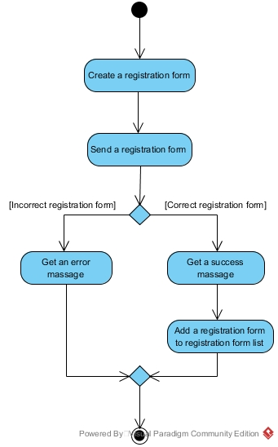

Activity Diagram #2 : Use Case - Login

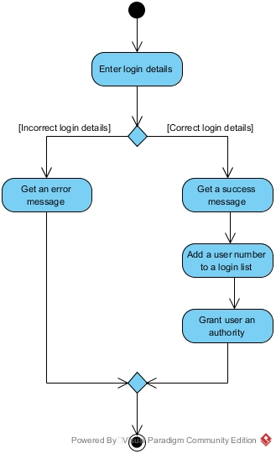

Activity Diagram #3 : Use Case - Change account information

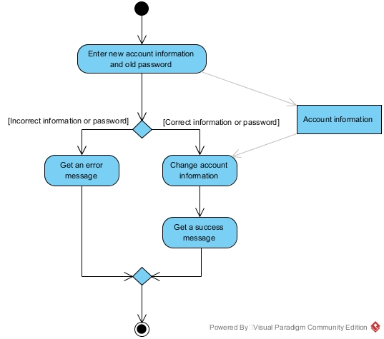

Activity Diagram #4 : Use Case - Delete account

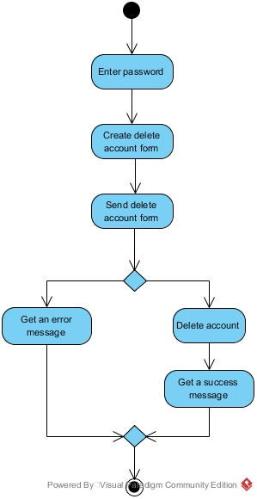

Activity Diagram #5 : Use Case - Search service

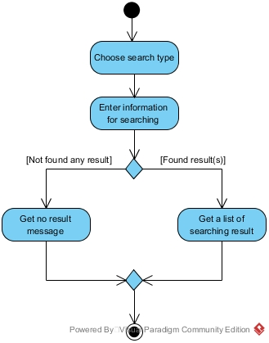

Activity Diagram #6 : Use Case - Reserve provider

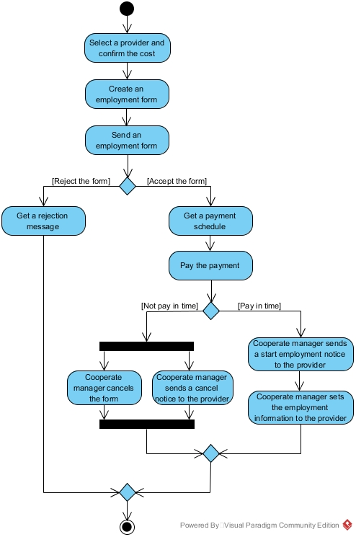

Activity Diagram #7 : Use Case - Reserve provider

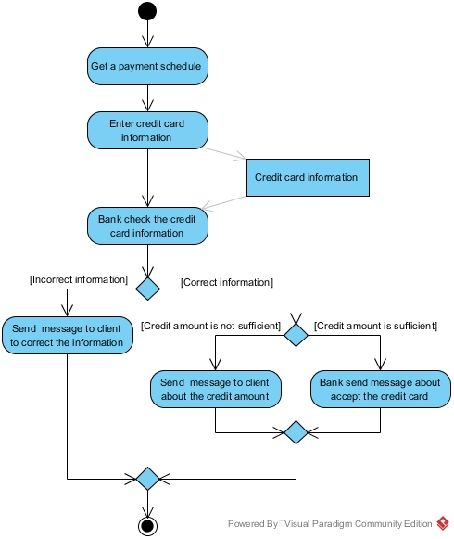

Activity Diagram #8 : Use Case - Finish reservation

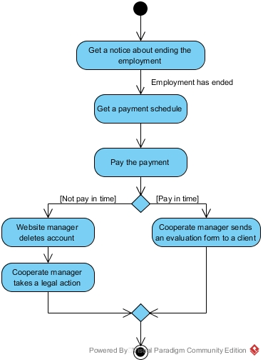

Activity Diagram #9 : Use Case - Cancel reservation

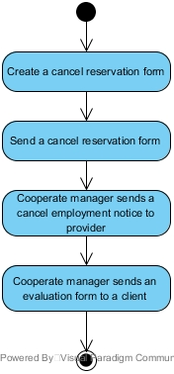

Activity Diagram #10 : Use Case - Update provider’s rating

